**Great Lumley Parish Council**

Meeting of Great Lumley Parish Council

Monday 21st December 2020 at 6.30 pm

This meeting will be held virtually using the zoom online platform <https://us02web.zoom.us/j/89260180934>

Meeting ID: 892 6018 0934 (No password)

You are summoned to attend the above-mentioned meeting of the Parish Council

**AGENDA**

1. **Declarations of Interest:**

To note any declarations of interest from members of the Council, in items on the agenda

1. **Public Participation:**

There will be no public participation at this meeting

1. **Community Centre**

To consider the licence to occupy the Community Centre by Great Lumley Community Venture

To consider the future of the Millennium Green Play area in view of additional funding being available for a new play area (JR)

To consider the restrictive covenants placed on the bowling green area

1. **Budget for 2021/2022**

To consider the budget for the 2021/22 financial year

1. **Items to be discussed following the Exclusion of the Public and Press under The Public Bodies (Admission to Meetings) Act 1960 Sec 1 (2)**

To consider / adopt the revised business plan for the Community Centre Asset Transfer

1. **Date of next meeting:**

To confirm the date of the next meeting as Tuesday 5th January 2021

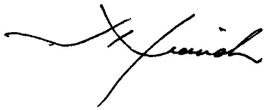

Signed: Parish Clerk

Website [www.greatlumleyparishcouncil.org](http://www.greatlumleyparishcouncil.org) Email: [greatlumleyparish@hotmail.com](mailto:greatlumleyparish@hotmail.com)